Chapter 15, Solution 35.

- Let 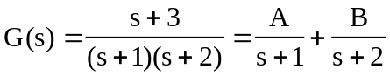

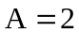, 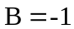

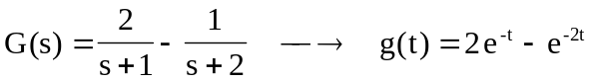

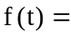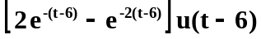

- Let 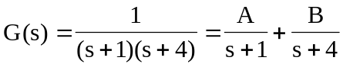

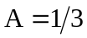, 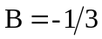

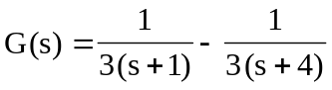

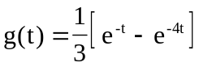

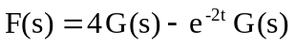

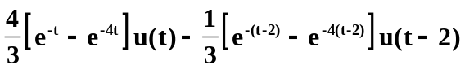

- Let 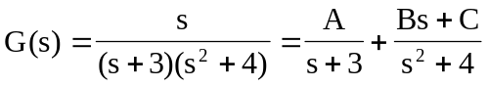

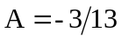

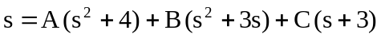

Equating coefficients :
 